The Tree4life Welcome Pack

The Tree4life Project

The NHS SMASH team working in Partnership with the Cherry Tree Community Centre, a charity based in Beverley, are delivering the SMASH Grows’ Seeds of Change Project & Tree 4 life Project.

The project was written following Young People experiencing nearly 2 years of remote learning, isolation, school closures and restrictions caused by the Covid-19 pandemic that people have not faced in over 50 years. The project is a great opportunity for Young People to re-connect with their schools, teachers and environment whilst learning about the eco system and the positive impact trees have on our everyday life.

This project aims to highlight the importance of coming together to understand and celebrate emotional & mental health wellbeing and its relationship to nature and how nature can be used as a tool to support and maintain good emotional wellbeing.

The Tree4life project hopes to create a sense of belonging in our community and support the positive impact on the environment around us. The project aims to leave a legacy within schools across Hull and East Riding to demonstrate what we do today will impact on tomorrow & our future environment. By planting the trees today, we can improve tomorrow.

We welcome schools to grow with this project and celebrate our environment, its amazing young people, and the fantastic work they do!

How to care for my Trees

Weeding in the first couple of years after planting will reduce competition for ground water and nutrients. Pull up any grass or weeds inside and around your spirals. We can't over-state the value of this, and the significant difference it will make to tree establishment and survival.

How can I prevent weeds from growing?
You can suppress weeds by using mulch, such as bark chips or straw, around each tree. Spread to a depth of around 10cm to prevent it from being blown away or dispersed and top it up annually. You can also buy mulch mats which can be pegged into the ground. Aim to keep a 1m diameter area around the tree clear of weeds and grass for the first 2-3 years.

Should I replace canes and spirals that have been lost?

New trees will not have anchored themselves into the ground properly, so the canes and spirals are important. Check your trees are still upright and that your spirals and canes are pushed firmly into the soil

When do I remove the spirals and canes?

When the trees reach three metres in height, the spirals have done their job and will start to unravel. They could hamper growth if left so this is the perfect time to remove them

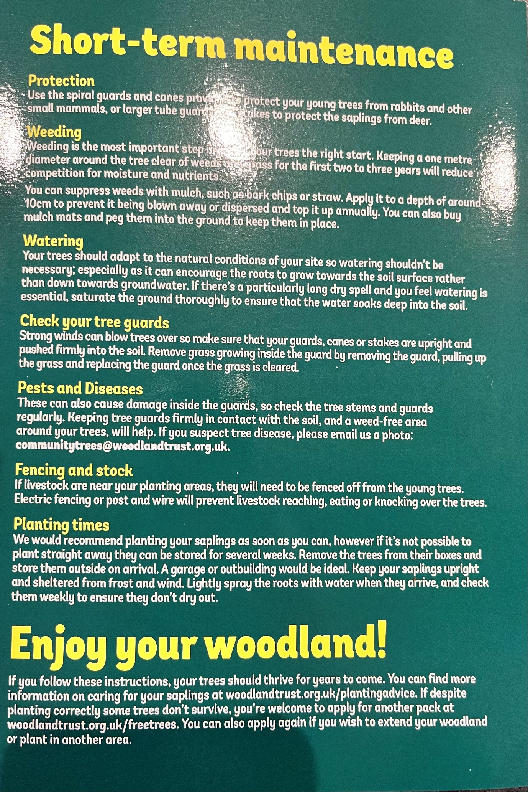
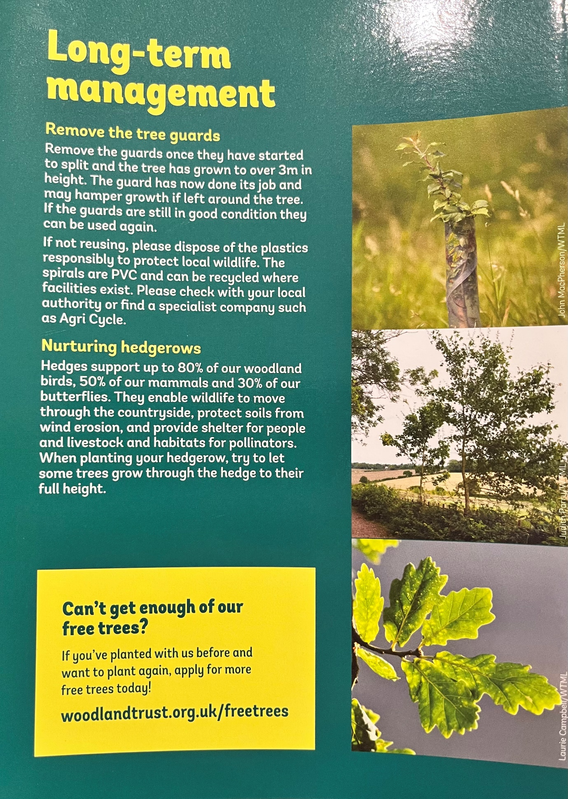

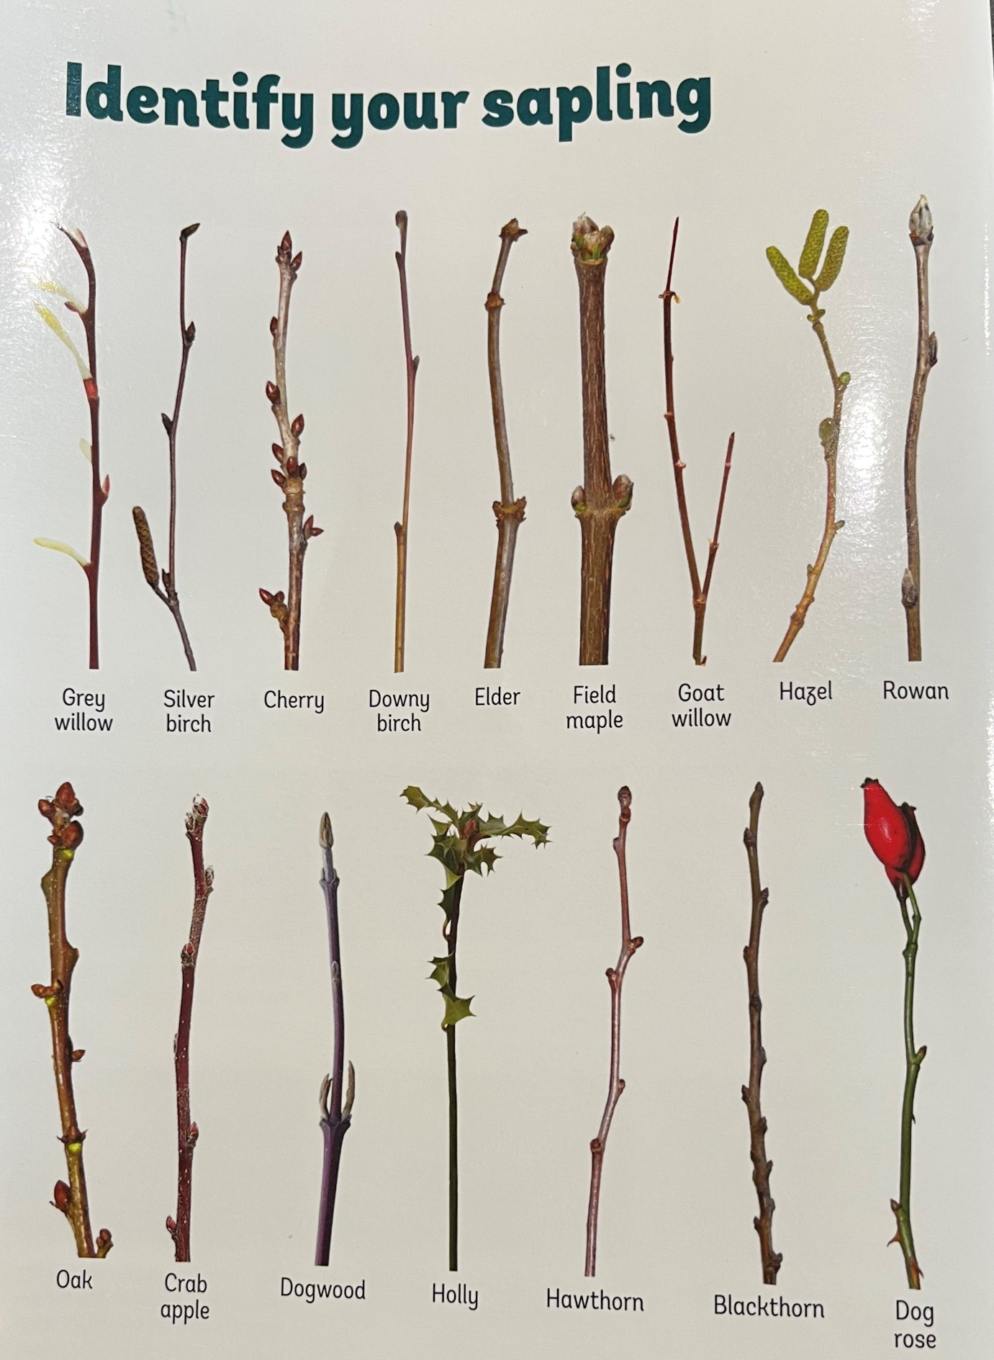
The SMASH Grows project have more saplings arriving in March if you’d wish to grow your project further and we also have a Seeds of Change project for Spring.

The Seeds of Change project is for young people to learn how to grow produce from seeds. When young people connect with nature and learn to grow plants from seed they learn how to care and nature plants. Young people make a unique connection between themselves and the plants. They learn that plants are like people and that we all need good foundations, good support & love, nutrients and water and the space, time and opportunity to thrive. Young people are as important to our environment and eco system as the plants. The produce grown will then be shared and donated between the young people, the schools and a local Charity supporting SMASH Grows, The Cherry Tree Centre, based in Beverley. If you are interested in taking part in this project, please contact the SMASH team via the email below
hnf-tr.earlyinterventions@nhs.net

